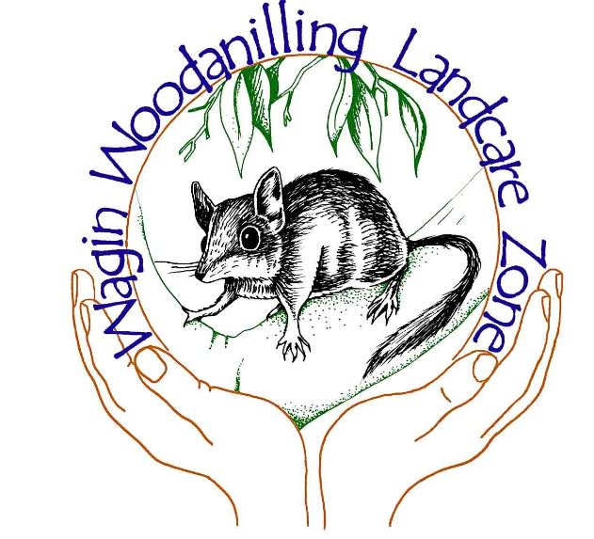
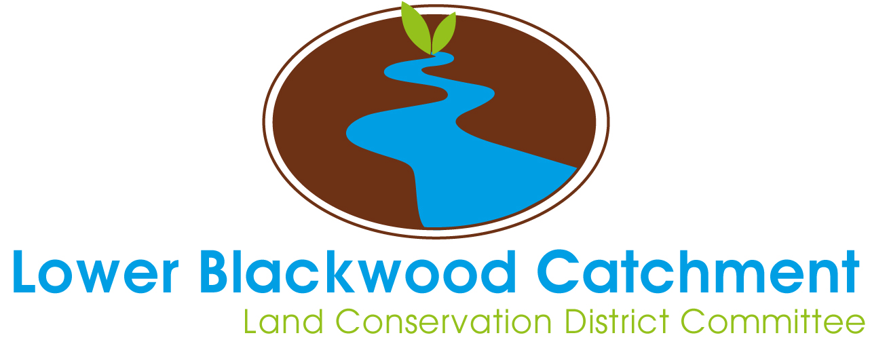
It’s time for us to prepare our new Landcare Strategy for the entire Blackwood and for our catchment
Strategy Making

DISCOVERY QUESTIONNAIRE
Our new Strategy will be our leadership tool. It will set our direction for the long term, it will inspire and motivate us, and it will help us deal with future change. It will also become the higher order document we use to determine the key objectives for our individualised Catchment Management Plans in each zone. Soon, you, your Committees, Landcare Officers and invested landholders will be gathering together at a series of workshops for stimulating and intensive strategising. Before we do this, we are all going to complete this questionnaire.

About this questionnaire
This questionnaire will warm us up to strategy making and give us a head start on strategising. It requires us to focus on the strengths that already exist within Katanning Landcare, and to think about what could, should and must happen in the future. It allows us to identify important strategic themes before we get together at the workshops, so we can move quickly into generating the next level of ideas and analysis.

About the results
When you have completed your questionnaire, you will email it directly back to Rebecca Cotton. Rebecca is an external strategy specialist helping us develop our new Strategy. She will analyse the results and prepare a report, which will be distributed back to you prior to the workshop. The themes identified in the report will then be presented and used at the workshop.

About confidentiality
Only Rebecca will know who completed each questionnaire, and you do not have to provide your name on the questionnaire form. You can say whatever you like and be confident that your individual statements will not be repeated, and you will not be personally identified.

Please email your completed survey directly back to Rebecca at:

rebecca.cotton@westnet.com.au

by 23rd March 2016

Section 1: Your best experiences – your high point
Please take a moment to reflect on your association with Katanning Landcare. Think of a positive Landcare experience: a time when things were going “great guns” for you. If you can’t think of a Landcare experience, try to think of a high point elsewhere. Once you have this experience clearly in your mind, think about what made it possible. Please type your answers to the specific questions below.
Q1a) | What part did you play in this ‘best experience’?  (e.g. I was facilitating the process, I was organising everyone, I was working alone on something I’m really passionate about, I was part of the team that made the discovery, I was in a leadership role…)
<type here>

Q1b) | What was so good about it? What made it a BEST experience?  (e.g. I loved the team spirit, we were on the cutting edge of science, I was having lots of fun, I had a chance to work on my own, I was making a real difference to the environment…)
<type here>

Q1c) | Was the Committee or Landcare Officer doing something at this time to contribute to this experience?  (If yes, please explain what they were doing, e.g. they supported me all the way, they made sure I had all the resources I needed, they were giving me lots of useful advice…)
<type here>

Q1d) | Was the group you were working with at the time doing something to contribute to this experience?  (If yes, please explain what they were doing, e.g. they took on some of my workload so I could concentrate solely on the work, they were being really cooperative, they were all pitching in and doing their bit…)
<type here>

Q1e) | Were there any systems or structures that supported you at the time?  If yes, please explain what they were (e.g. plans, practices, procedures, funding applications...)
<type here>

Section 2: Your hopes for the future of Katanning Landcare
What are your hopes for the future of Katanning Landcare as a whole? Visualise it in 20 years’ time, as it would be if you could have everything you want for it. This is the ideal, perfect future as you imagine it.
Q2a) | What do you want Katanning Landcare to look like in 20 years? What do you want it to be achieving?  (Be bold and brave – nobody is judging you and there is no right or wrong – this is the way YOU want it. If you can’t quite picture the whole organisation in 20 years’ time, try thinking about your area, your team.)
<type here>

Q2b) | What do you want Katanning Landcare to be doing MORE of in 20 years?  (Again, if you can’t quite picture the whole organisation, try thinking about your area.)
<type here>

Q2c) | What do you want Katanning Landcare to be doing LESS of in 20 years?  (Again, if you can’t quite picture the whole organisation, try thinking about your area.)
<type here>

Section 3: Key success factors for Katanning Landcare
Q3) | Keep your 20 year vision for Katanning Landcare in your mind…what are the main things that would indicate to you that it is functioning as well as it possibly can by then?  There is no right or wrong answer here. You can say anything you like. You know what it looks like when it’s working well.  How will you know when you are providing the best services possible? How will you know when your team is functioning at its best? How will you know when the organisation is functioning at its best?
<type here>

Section 4: Most important issues for the next 5 years
Q4a) | What do you think are the most important issues that your local catchment will face over the next five years?  (i.e. think external: environments, flora and fauna, systems, clients, communities and organisations you target – all those environments, individuals, groups and communities with whom you have interactions and interventions.)
 | 1. <type here>
 | 2. <type here>
 | 3. <type here>
 | 4. <type here>
 | 5. <type here>

Q4b) | What do you think are the most important issues that the Blackwood River Catchment will face over the next five years?  (i.e. think external: environments, flora and fauna, systems, clients, communities and organisations you target – all those environments, individuals, groups and communities with whom you have interactions and interventions.)
 | 1. <type here>
 | 2. <type here>
 | 3. <type here>
 | 4. <type here>
 | 5. <type here>

Q4c) | What do you think are the most important issues Katanning Landcare will face as an organisational entity over the next five years?  (i.e. think internal: organisational development, workforce capability and workplace-specific issues.)
 | 1. <type here>
 | 2. <type here>
 | 3. <type here>
 | 4. <type here>
 | 5. <type here>

Section 5: Anything else you’d like to add
If there is anything else that you’d like to add that you think will help with the strategy-making process, please type it in the box below. We welcome all information that will help us make the best possible decisions for the future.
<type here>

Thank you for taking the time to complete this questionnaire. The results will be analysed and presented back to you very soon.

Please email your completed survey directly back to Rebecca at:

rebecca.cotton@westnet.com.au by 23rd March 2016

